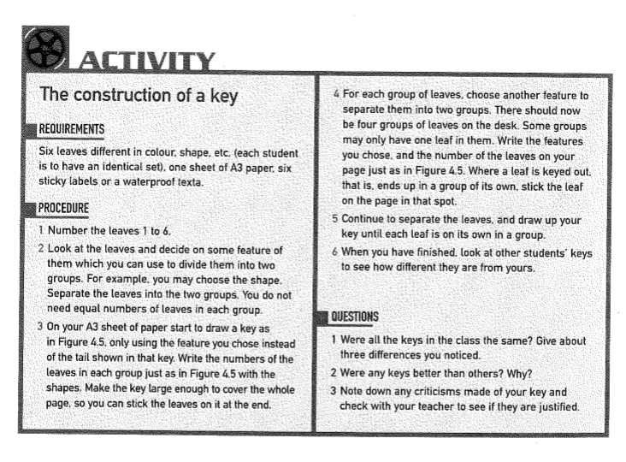

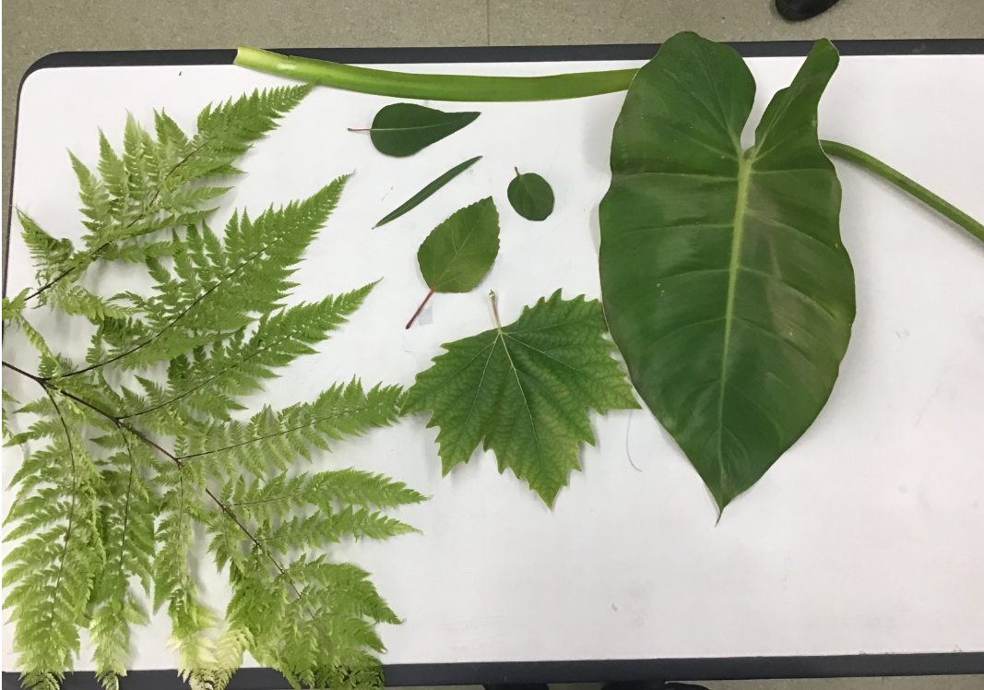

Look at your key. Think about ways that you could classify these leaves all over again in different ways and therefore how your key might be different each time.
For example you may use single leaf attached vs multiple leaves, or single main vein or multiple direction veins.
When looking for leaf characters features you might consider include:
- Whether leaf has teeth or prickles
- Leaf edge is smooth or wavy
- Colour of leaf stalk
- Size of leaf stalk
- Number of main veins
- Presence of side veins coming off main vein etc

